A PROJECT REPORT ON

MAMDANI FUZZY SYSTEM FOR STUDENT EVALUATION
SUBMITTED TO THE SAVITRIBAI PHULE PUNE UNIVERSITY, PUNE IN PARTIAL FULFILLMENT OF THE REQUIREMENTS FOR THE AWARD OF THE DEGREE
BACHELOR OF ENGINEERING
In
COMPUTER ENGINEERING
Of

SAVITRIBAI PHULE PUNE UNIVERSITY
By

AKSHAY SHEKADE B150234372 AMIT WAKADE B150234412 VISHAL TAYADE B150234402 SHUBHAM MAKAR B150234310



DEPARTMENT OF COMPUTER ENGINEERING

SINHGAD COLLEGE OF ENGINEERING, PUNE-41
Accredited by NAAC

Sinhgad Technical Education Society,
Sinhgad College of Engineering , Pune-41
Department of Computer Engineering

CERTIFICATE
This is to certify that the project report entitled

Mamdani Fuzzy System for Student Evaluation

Submitted by

AKSHAY SHEKADE | B150234372
AMIT WAKADE | B150234412
VISHAL TAYADE | B150234402
SHUBHAM MAKAR | B150234310
is a bonafide work carried out and is approved for the partial fulfilment of the requirements of Savitribai Phule Pune University, Pune for the award of the degree of Bachelor of Engineering (Computer Engineering) during the year 2019-20.

Prof. Ankita Kotalwar Prof. M. P. Wankhade
Guide Head
Department of Computer Engineering Department of Computer Engineering

Dr. S.D. Lokhande
Principal
Sinhgad College of Engineering

ACKNOWLEDGEMENT
We feel great pleasure in expressing our deepest sense of gratitude and sincere thanks to our guide Prof. Ankita Kotalwar for her valuable guidance during the Project work, without which it would have been very difficult task. I have no words to express my sincere thanks for valuable guidance, extreme assistance and cooperation extended to all the Staff Members of our Department.
This acknowledgement would be incomplete without expressing our special thanks to Prof. M.P. Wankhade Head of the Department (Computer Engineering) for his support during the work.
We would also like to extend our heartfelt gratitude to our Principal, Dr. S. D. Lokhande who provided a lot of valuable support, mostly being behind the veils of college bureaucracy.
Last but not least we would like to thank all the Teaching, Non- Teaching staff members of our Department, our parents and colleagues those who helped us directly or indirectly for completing this Project successfully.

ABSTRACT
In educational institutions the success is measured by academic performance, or how well a student meets standards set out by governmental educational policies and/or the institutional rules and regulations. This study proposes a new performance evaluation method based on fuzzy logic systems. In our method, we consider three characteristics for one academic course that involves exam1, theoretical exam2 and practical exam3. Then with using fuzzy logic based on Mamdani technique we get a new approach for evaluating students. Results of our methods for some real samples shows that our approach can be practical method for evaluating students’ performance in the university.

Institutes evaluate students’ academic performance through a conventional evaluation system which is framed by the institutes under educational policies and/or the institutional rules and regulations. This research study proposes a new fuzzy logic-based performance evaluation method. In this method, we consider three parameters attendance, internal marks and external marks which are considered to evaluate students in an IT related undergraduate course. Then an expert system using fuzzy logic based on Mamdani technique has been designed and tested on a real sample and the two results have been compared.

List of Figures
Name Page No
Membership function of input variable Attendance (f1) 14
Membership function of input variable Internal Marks (f2) 15
Membership function of input variable External Marks (f3) 16
FIS System with input and output 17

List of Tables
Name Page No
Literature Survey 10
Input Variables (elements) of the Proposed Evaluation Mode 42
Calculation of Crisp Values of Students’ Attendance 42
Students’ Attendance in terms of Linguistic Variables 42
Calculation of Crisp Values of Internal Marks 42
Internal Marks in terms of Linguistic Variables 42
Calculation of Crisp Values of External Marks 42
Range for Linguistic Variables of the External Marks for fuzzy Input (f3) 42
Represents the rules for the three inputs and corresponding outputs 42
Students’ Overall Performance in terms of Linguistic Variables 42
Comparison of Students’ Performance 42
t-test Two-Sample Assuming Equal Variances 42

ABBREVIATION
- FIS : Fuzzy Inference System
- FL : Fuzzy Logic

TITLE CONTENTS PAGE NO
Certificate 2
Acknowledgment 3
Abstract 4
List of Figures 5
List of Tables 5
Abbreviation 6

Chapter No. Title Page No.

1. INTRODUCTION
1.1. Background and Basics...........................................................9
1.2. Literature Survey....................................................................10
1.3. Motivation ………………………………………………….11

2. PROJECT MANAGEMENT
2.1. Project Requirements
2.1.1 Performance Requirements...........................……….12
2.1.2 Safety Requirements………………………………..12
2.1.3 Security Requirements……………………………...12
2.1.4 System Security…..…………………………………12

3. IMPLEMENTATION
3.1. Crisp Value (Data)................................................................ 19

6. RESULT AND DISCUSSION
6.1. Main GUI Snapshots...........................................................................44
6.2. Graphs..................................................................................................... 47
6.3. Comparison………………………………………………….48
7. CONCLUSION

8.REFERENCES

Chapter 1
Introduction

1.1. Background and Basics
Students’ academic success is evaluated by their performance in exams conducted by the institutes or Universities. Considering the high demand of IT professionals and the gap between academia and IT Industry it is important that we must explore the possibilities of automated system which can effectively evaluate the performance of students in computer science and IT related courses. The authors had proposed an expert system using fuzzy logic in another paper. The result generated by the expert system is then compared with the result of the convention method to test the difference in the result of two systems.
Fuzzy logic was put forward earliest in 1965 by L.A. Zadeh. One of the primary applications of fuzzy logic was subway systems in Sendai city of Japan. Educational assessment is the process of documenting, usually in measurable terms, knowledge, based on the criteria incorporated. The assessment is formally defined as a measure of skills, attitudes and belief. In recent times, towards describing what a student has learned or can do in greater detail different types of documentations are in use. This can be done in performance evaluation by Fuzzy logic technique. In order to apply the fuzzy set in the education domain effectively, there have been a lot efforts in defining the effective membership. Bai and Chen define fuzzy membership functions for fuzzy rules.

Literature Review
For last few years, fuzzy logic theory is being used in the education system. Implementation of the fuzzy logic for various activities of assessment of students’ performance such as evaluation of answer scripts of students in an examination, evaluation of lab examination, projects evaluation and many more. Fuzzy rules have been developed to check how fuzzy rules can be used to model and evaluate the achievement of the learning outcomes in information systems courses for last few years, fuzzy logic theory is being used in the education system. Implementation of the fuzzy logic for various activities of assessment of students’ performance such as evaluation of answer scripts of students in an examination, evaluation of lab examination, projects evaluation and many more. Fuzzy rules have been developed to check how fuzzy rules can be used to model and evaluate the achievement of the learning outcomes in information systems courses.

1.2. Literature Survey
S.No. | Paper Name | Overview | Limitation
1. | Use of Fuzzy Logic in Evaluating Students’ Learning Achievement. | The main purpose of this research is to implement fuzzy logic for student achievements. | Only achievement is considered for this model.
2. | Fuzzy Rules in Assessing Student Learning Outcomes. |  | Student Performance is not evaluated in this system.
  The present work showed the ability of fuzzy system in student learning outcomes.
3. | Using Fuzzy Logic for Grading Highly Subjective Assessment Material | The model is use for grading the highly subjective assessment material. | Student Performance is not evaluated in this system.
Table 1. Literature Survey

1.3 Motivation
It was proposed to use of the fuzzy set technique to be applied in the evaluation process of the industrial automation systems learning area, which aimed to lessen the evaluation complexity and ambiguity. Neural fuzzy sets containing fuzzy linguistic constructors in rule and query expressions and logical statements were developed, to model the structure of fuzzy linguistic expressions. It has also been investigated whether use of fuzzy logic is suitable for the resolutions of achieving fair assessment.
To apply fuzzy logic along with standard numerical grading, a case study was carried out for a poster competition for postgraduates. It was observed that that this fuzzy logic based grading method has many advantages over the traditional method. The outperformance of a Fuzzy Probabilistic Neural Network model to predict personalized student performance was observed in comparison to traditional statistical models as well as traditional back-propagation neural networks. An approach based on fuzzy set was presented to evaluate the results of student-centered learning where there was participation of students to determine the criteria for assessment with their weightage.
It was also found in another study that the evaluation with Fuzzy Logic renders great flexibility and robustness in the evaluation process. A dynamic automated converter of crisp set into fuzzy set based on C-Means clustering algorithm was developed and tested. This system has the capabilities to handle imprecise and missing data. The fuzzy inference system has also been used to obtain Performance of Students for different input values of Teaching Effectiveness, Student Attendance, and other Facilities .
These researches have been the motivation to develop a fuzzy expert system for the evaluation system followed in the institutes of India and test the results for the students of undergraduate IT related courses.

Chapter 2
Project Management

  - Project Requirements:
2.1.1. Performance Requirements:
The application should be adaptable to various situations where different types of inputs provided by different users.
The system must be robust enough to handle any data which is provided as the input to it and should be able to compute the correct output.
2.1.2. Safety Requirements:
Users’ credentials should be transferred to the server safely and securely. The result should not take more time to display or more time to send the mail.

    - Security Requirements
Authentication and privacy of the users must be maintained.

    - System Security
Individual will have their separate login and their login credential is included in the database. User will have their login and password, so that their profile will not be accessible to any other user

Libraries Used:
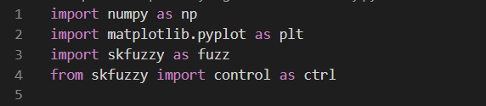

Chapter 3
Implementation

The fuzzy expert system designed by the authors is explained as below. The fuzzy logic model comprises of following stages:
3.1. Crisp Value (Data):
The values for input variables may be collected from the records of the students’ end term result with internal assessment (f1), external Assessment (f2) and overall attendance of the Semester (f3) shown in Table

TABLE I. INPUT VARIABLES (ELEMENTS) OF THE PROPOSED EVALUATION MODE
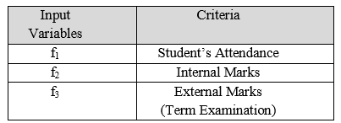

3.2. Fuzzification (Fuzzy Input Value):
Fuzzification of three input variables (elements) is done by using variable which are similar to verbal human language such as average, good, very good, excellent etc. Then each input variable is assigned a trapezoidal Membership function, defined by a lower limit ‘a’, an upper limit ‘d’, a lower support limit ‘b’, and an upper support limit ‘c’, where a < b < c < d, for the degree of association for respective linguistic variables is represented in eqn. (1).

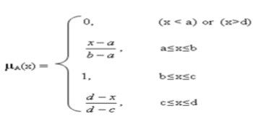
The process of fuzzification of the three input variable is as follows

1) Fuzzification of Input Variable Students 'Attendance: The Students’ attendance in the subject Linux was taken every day in each lecture. The percentage of attendance is calculated from the number of classes attended by the students in the subject throughout one term of four months.
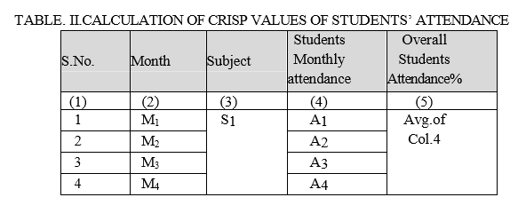

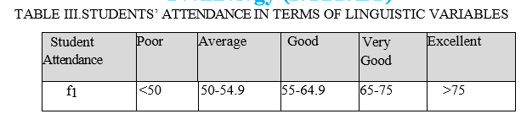

Membership Function of the input variable Students Attendance (f1) is shown in Fig.1.
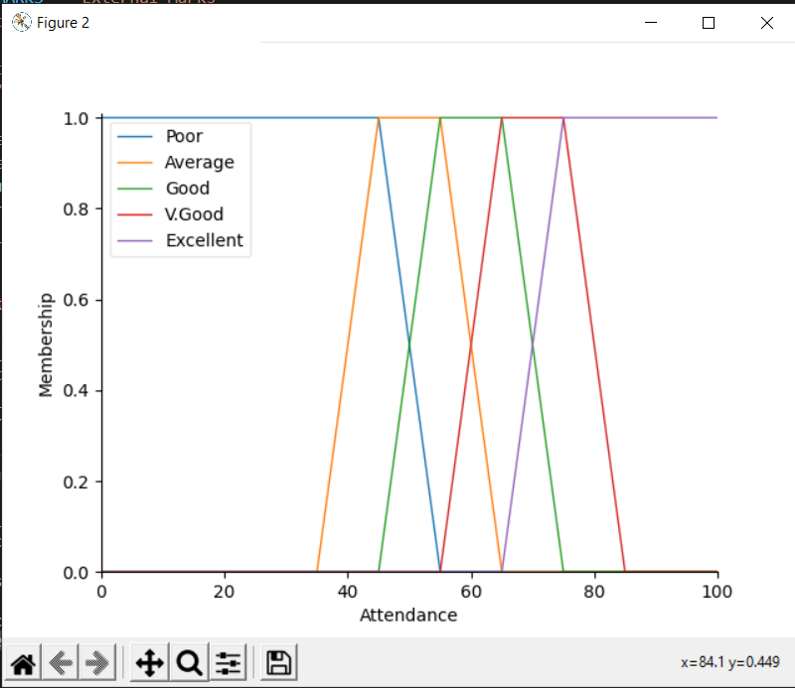
Fig.1 Membership function of input variable Attendance (f1)

2) Fuzzification of Input Variable Internal Marks

TABLE IV. CALCULATIONS OF CRISP VALUES OF INTERNAL MARKS
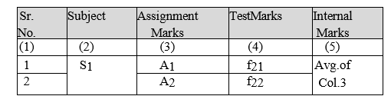
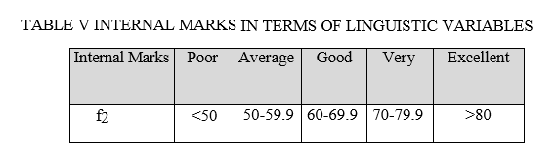
Membership Function of the input variable Internal Marks (f2) is shown in Fig.2
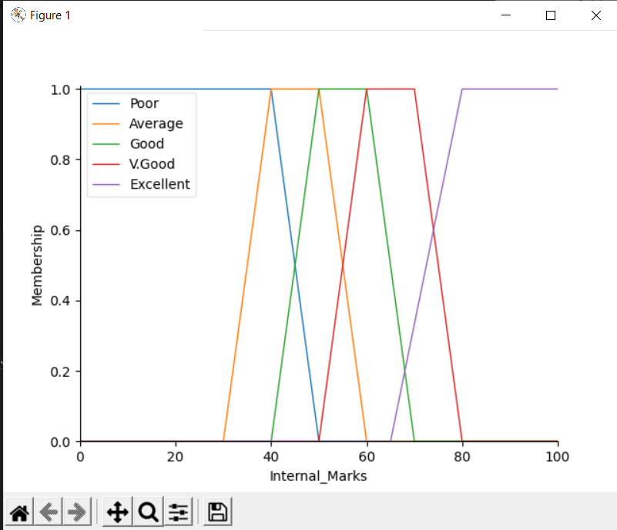

Fig.2.Membership function of input variable Internal Marks (f2)
3) Fuzzification of Input Variable External Marks
After the end of the term, final exam is conducted for all subjects. The crisp value of external marks in Linux.
TABLE VI CALCULATION OF CRISP VALUE OF EXTERNAL MARK
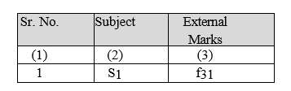
TABLEVII.RANGE FOR LINGUISTIC VARIABLES OF THE EXTERNAL MARKS FOR FUZZY INPUT F3
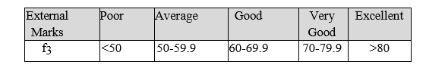

Membership Function of the input variable External Marks (f3) is shown in Fig.
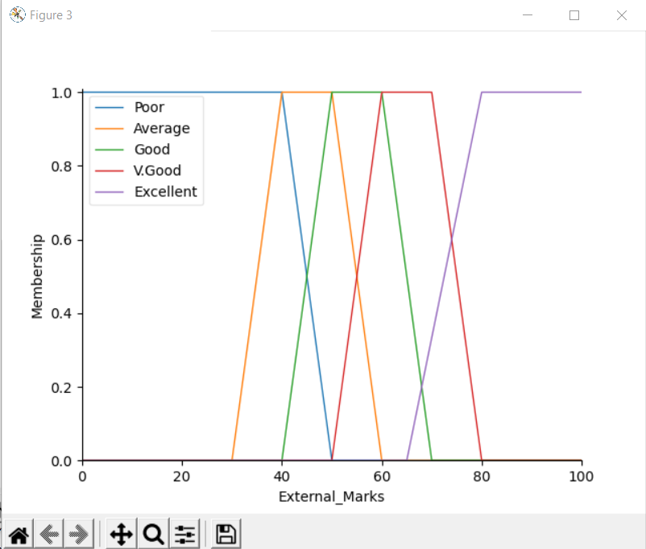
Fig.3.Membership function of input variable External Marks (f3)

3.3. Development of Fuzzy Rule and Inference Mechanism
To relate the inputs and output membership functions, fuzzy inference rules are used in inference process. These linguistics rules use “IF-THEN” statements. These rules are flexible and can be formulated depending upon the importance to be given to a particular input with the discussion with the academic experts.
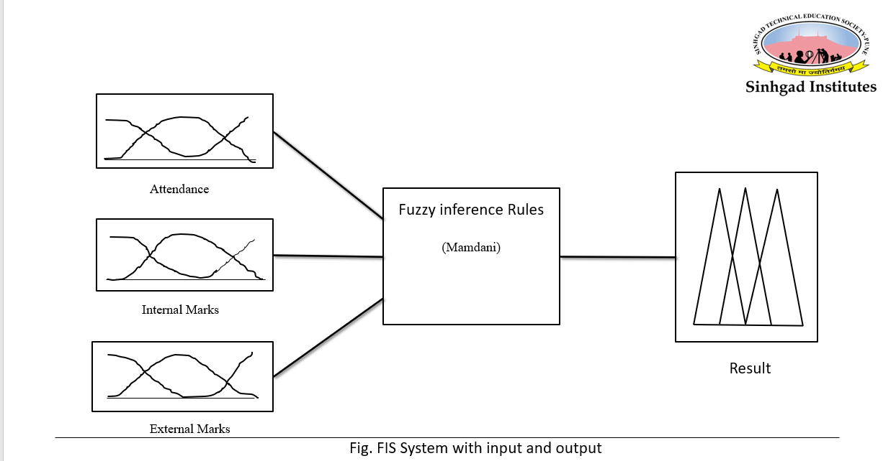
Fig.3.FIS System with input and output

Table VIII represents the rules for the three inputs and corresponding output.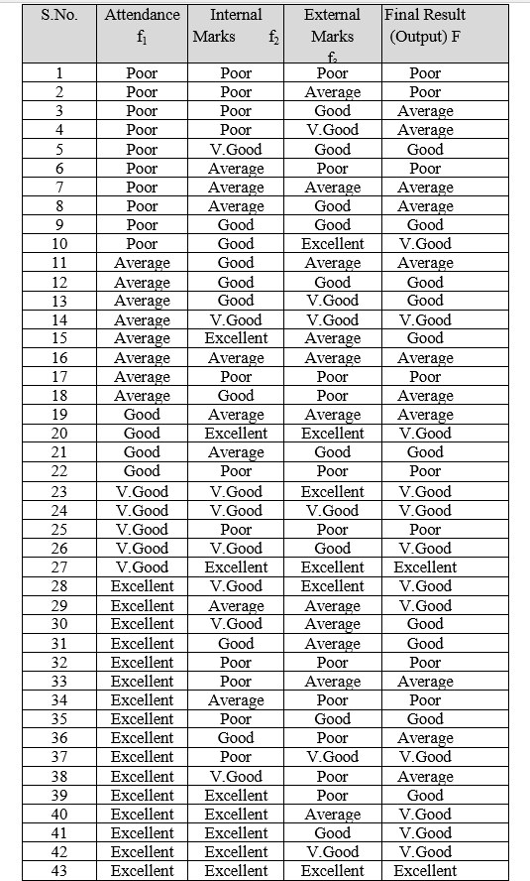
3.4. Defuzzification of Fuzzy Output (To Find Out The Final Result With The Help Of Suitable Defuzzification Method)
The output variable F is the students’ final performance. If the three input variables are expressed as f1, f2, f3 and membership functions of the three input variables are µ(f1), µ(f2), µ(f3.) respectively for rule k=1,2,3,4, ........r, then the membership function of the output variable F is given by equation (2).
µF(x)=Max k [min[µ(f1), µ(f2), µ(f3)]], k=1,2,3, 4, .... r (2)
This expression expresses the value of membership function for output variable overall performance for active rules for each input. The logical operator AND is used among the three inputs. Similar to the fuzzy linguistic variables of input we have used the linguistic variables for output which have been shown in Table IX
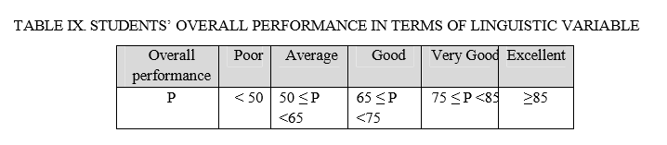

IV. EXPERIMENT RESULTS

In this model, we have used MATLAB (version R2013a) for implementing proposed fuzzy system for student s’ academic performance evaluation. The proposed Fuzzy Expert system was tested with 54 Student’s term attendance, internal marks and external marks in the subject Linux for one term. The result from the fuzzy expert system along with the final result from conventional method of assessment is shown in Table X. Two sample t-test was also performed on the two results obtained from conventional method and from fuzzy expert system which is shown in Table XI. The null hypothesis considered as that there is no difference in the mean value of two samples. (Two results are similar)
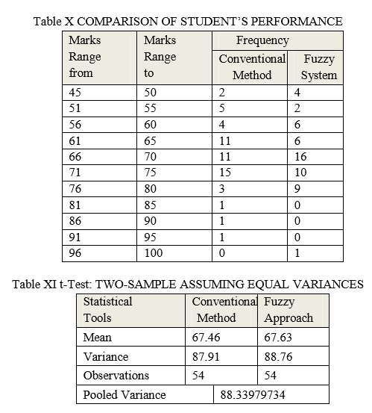

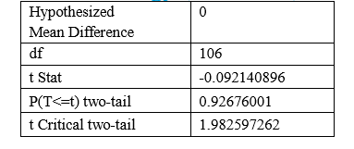

Conclusion
The t-test is conducted using MS Excel. As per value of t test we cannot reject the null hypothesis that two results are similar as p-value of test statistics is 0.927 (< 0.975) and the t-statistic is -0.09, which does not fall into the rejection region. In other words, we accept the null hypotheses that means conventional result is equal to the mean fuzzy system result with 95% confidence level. This shows that that the expert system can provide the same results as conventional method. Therefore, one can apply computer based Fuzzy System Approach in plane of time-consuming conventional method. However, in some cases, the variations in results from fuzzy system have been observed for some students who have same result through conventional method. It was due the difference in their attendance which shows that expert system incorporates input attendance effectively. On the contrary in the conventional system, for a regular course, a student must have mandatory attendance failing to which the student may not be allowed to appear in exams. This shows that the expert system provides flexibility to the inflexible conventional system which is greatly required in present age of technology.

References
[1] Narula, M.; Nagar, P., Fuzzy logic based expert system for students' performance evaluation, International Conference on Computing for Sustainable Global Development (INDIACom), 2015 , vol., no., pp.803-808
[2] Biswas, Application of fuzzy sets in student’s evaluation, Fuzzy Set and systems, pp. 187-194.
[3] Ibrahim Saleh, Seong-in Kim , A fuzzy system for evaluating students’ learning achievement. s.l. : Expert Systems with Applications.
[4] Bakal, Shilpa Ingoley & J.W. 2012, Use of Fuzzy Logic in Evaluating Students’ Learning Achievement, International Journal on Advanced Computer Engineering and Communication Technology (IJACECT), pp. 47-54.
[5] Rajiv Bhatt, Darshana Bhatt., Fuzzy Logic based Student Performance Evaluation Model for Practical Component of Engineering Institution Subjects, International Journal of Technology and Engineering Education , 2011, Vol. 8.
[6] Maria Samarakou, Andreas Papadakis, PantelisPrentakis, Dimitrios Karolidis, Spyros Athineos, A Fuzzy Model for Enhanced Student Evaluation, s.l. : The International Journal of Learning, Vol. 16. [

